SIMATS ENGINEERING
ASSESSMENT TOOL 2 - CONCEPT MAPPING
- YAVANIKA S
192521258
- Question 1: CPU, Memory, I/O and Bus Structures
The computer system functions as an integrated unit of three principal blocks: the Central Processing Unit (CPU), the Memory Unit, and the Input/Output (I/O) devices. These blocks do not operate in isolation - they communicate continuously through a shared communication pathway called the system bus, which itself is divided into an address bus, a data bus, and a control bus.

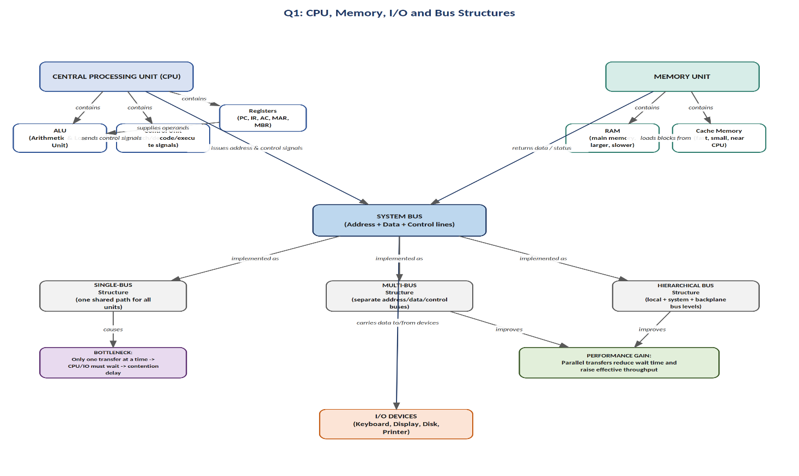
Concept Map

Figure 1.1 - Relationship between CPU, Memory, I/O and Bus Structures

Explanation of Relationships
The CPU is made up of the Arithmetic and Logic Unit (ALU), the Control Unit, and a set of Registers. The Control Unit generates timing and control signals that direct the ALU on which operation to perform, while the Registers (Program Counter, Instruction Register, Accumulator, Memory Address Register, Memory Buffer Register) temporarily hold data and addresses that the ALU operates upon. The Memory Unit is organised as a hierarchy: a small, fast Cache sits close to the CPU to reduce average access time, backed by the larger but slower main memory (RAM). I/O devices such as the keyboard, display, disk, and printer are connected to the rest of the system only through the bus - they never talk directly to the CPU or memory.
Data and control signals flow as follows: whenever the CPU needs to read or write, it places a memory or device address on the address bus and asserts the appropriate read/write line on the control bus. The addressed memory location or I/O port then places the requested data onto the data bus, which is picked up by the CPU or, in a direct-memory-access situation, by memory itself.

Process Flow of a Bus Transaction

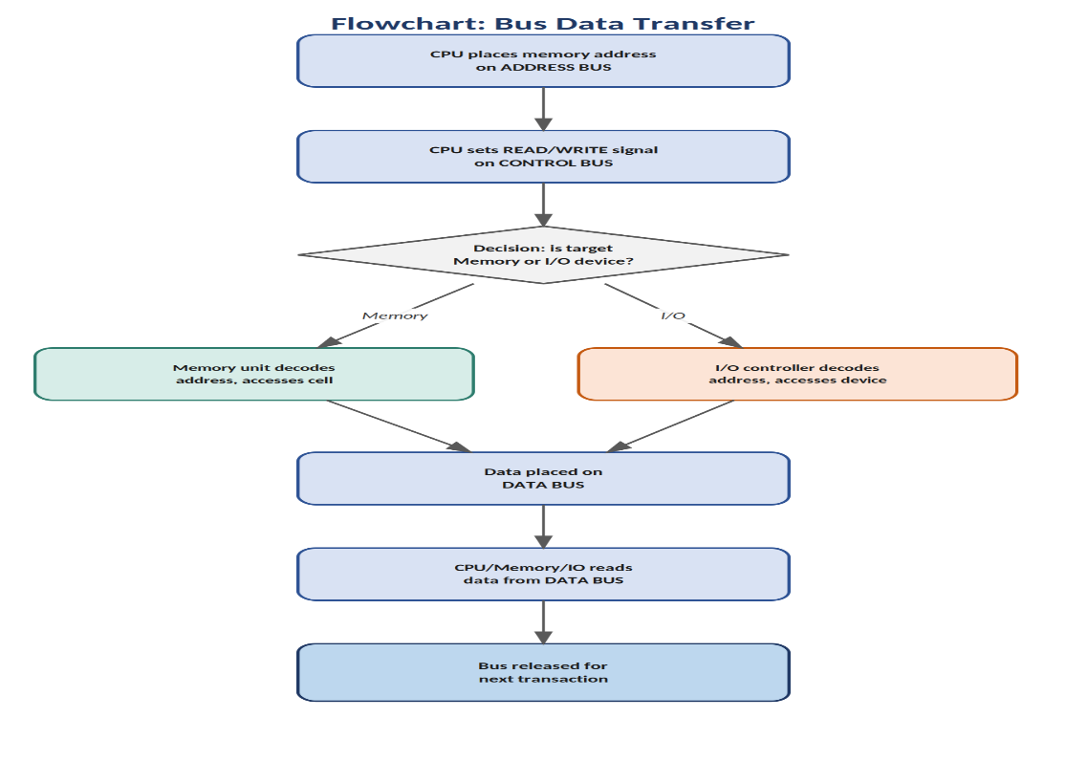

Figure 1.2 - Step-by-step flow of a single bus transaction

Single-bus, Multi-bus and Hierarchical Bus Structures
- Single-bus structure: one common set of lines is time-shared by the CPU, memory and every I/O device. It is simple and inexpensive but creates a bottleneck - only one transfer can occur at any instant, so a fast CPU is forced to wait for a slow I/O device before it can access memory.
- Multi-bus structure: separate, dedicated buses are provided (for example, a memory bus and an I/O bus), allowing the CPU to communicate with memory and I/O in parallel. This removes much of the contention seen in the single-bus design and improves overall throughput.
- Hierarchical bus structure: buses are arranged in levels - a fast local/processor bus for the CPU and cache, a system bus for main memory, and a slower expansion/backplane bus for peripheral devices. Because slow devices are isolated on their own level, they no longer hold up traffic between the CPU and memory, which is the key advantage of this arrangement in modern systems.
In short, the bus structure chosen directly determines system performance: single-bus designs are cheapest but bottleneck-prone, while multi-bus and hierarchical designs trade extra wiring/complexity for higher parallelism and reduced waiting time.

Question 2: Instruction Execution Cycle and CPU Performance
Every instruction a processor runs passes through the same basic execution cycle - Fetch, Decode, and Execute - and it is this repeated cycle that ultimately determines how fast a program runs. Understanding how the cycle links to CPI, clock cycles and execution time is central to reasoning about CPU performance.

Concept Map
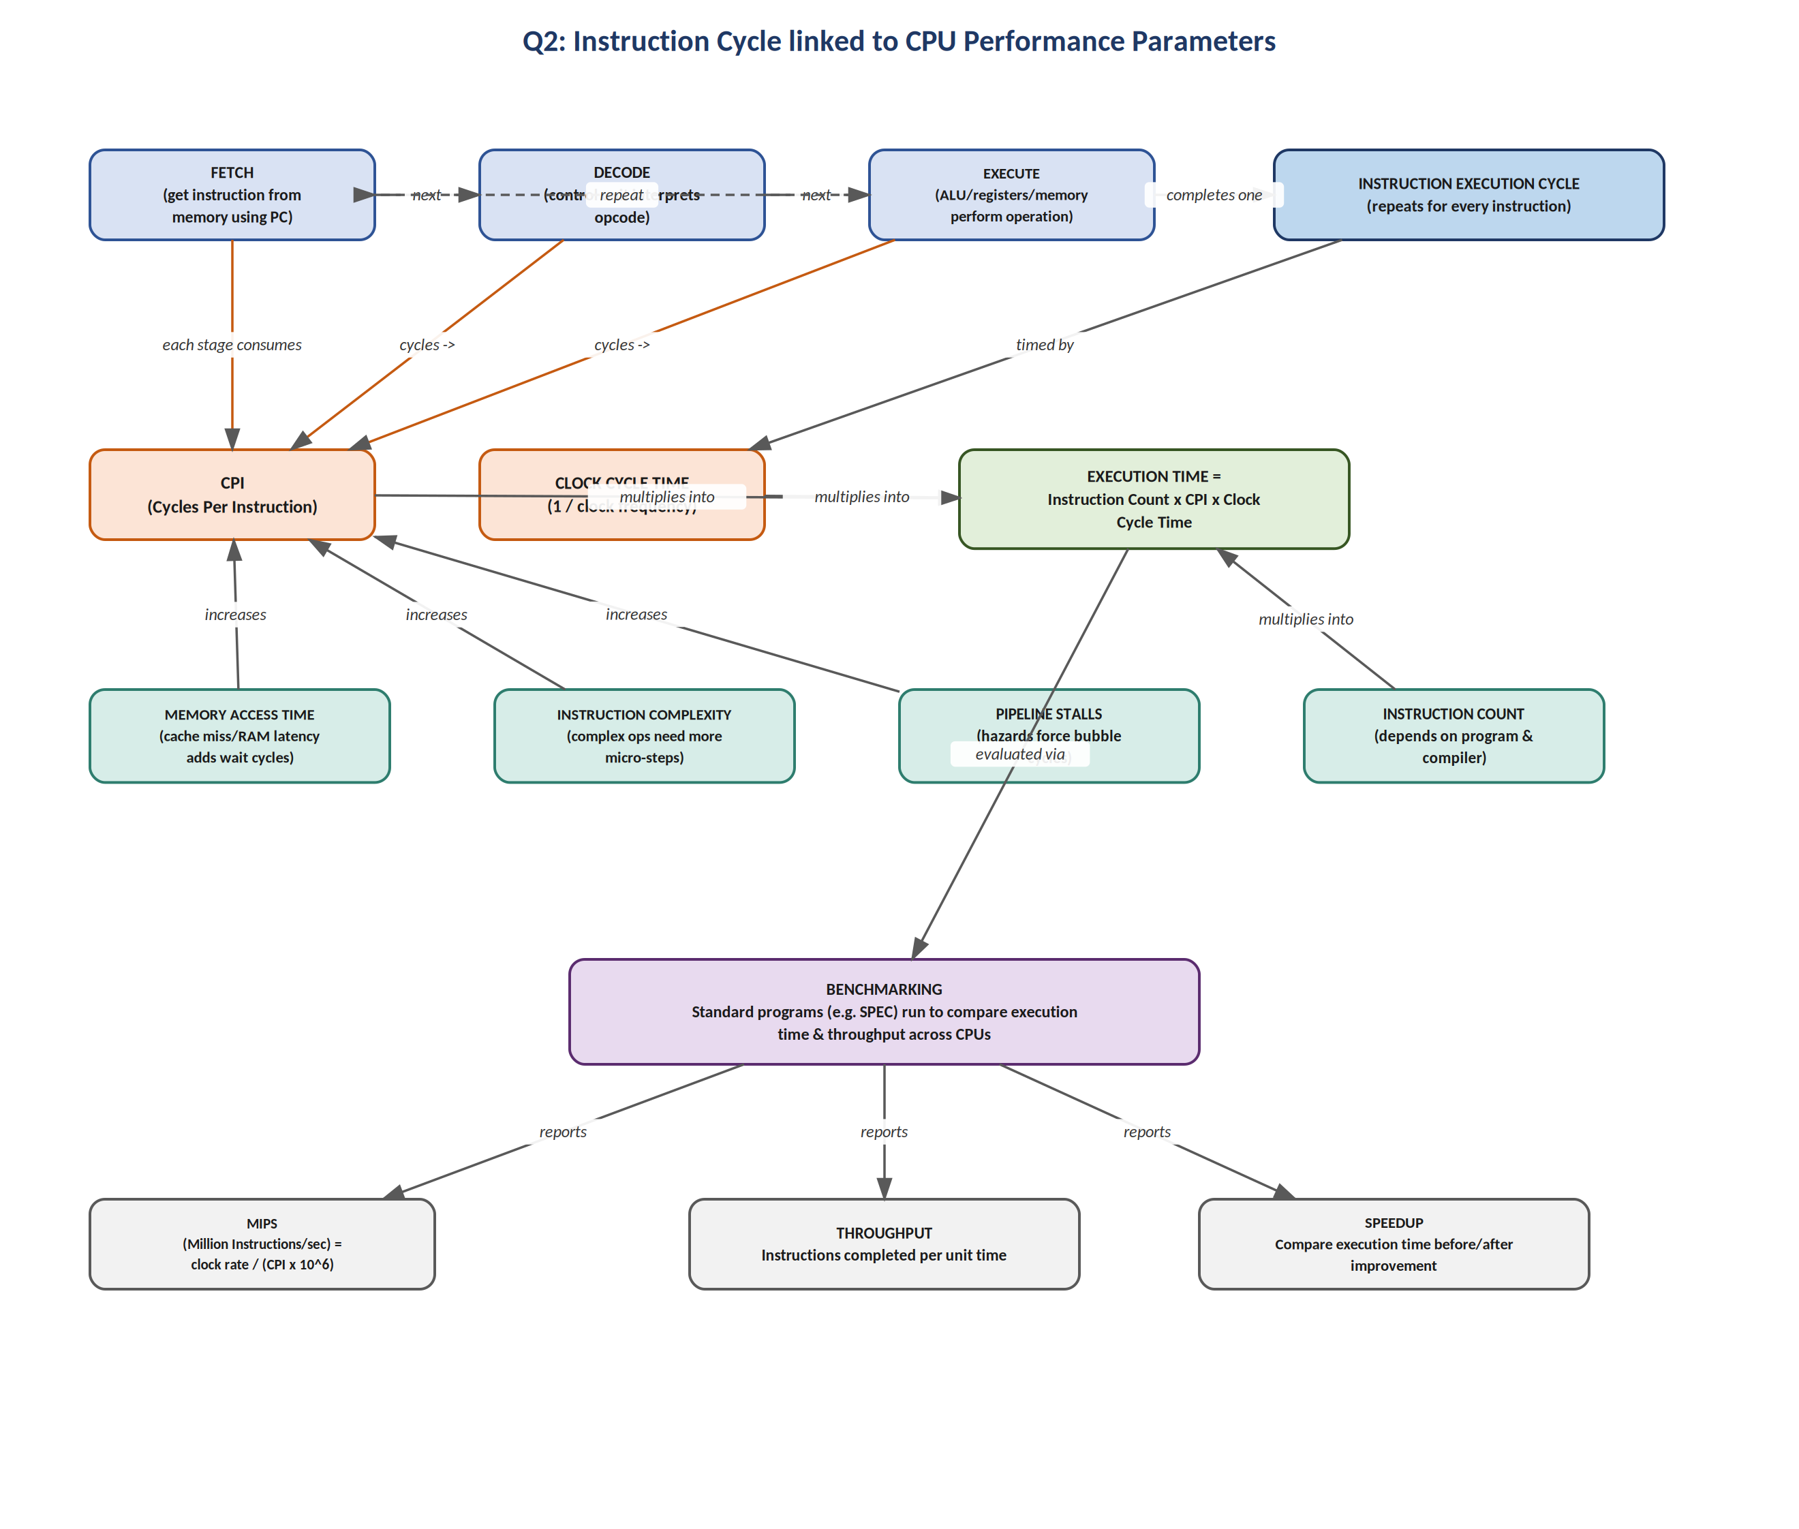
Figure 2.1 - Instruction cycle linked to CPU performance parameters

Explanation of Relationships
In the Fetch stage, the instruction pointed to by the Program Counter (PC) is read from memory into the Instruction Register, and the PC is incremented. In the Decode stage, the Control Unit interprets the opcode and determines which micro-operations are required. In the Execute stage, the ALU (or a memory/I/O access) actually carries out the operation and the result is stored back in a register or memory. Each of these stages consumes one or more clock cycles, and the average number of clock cycles required per instruction is called CPI (Cycles Per Instruction).

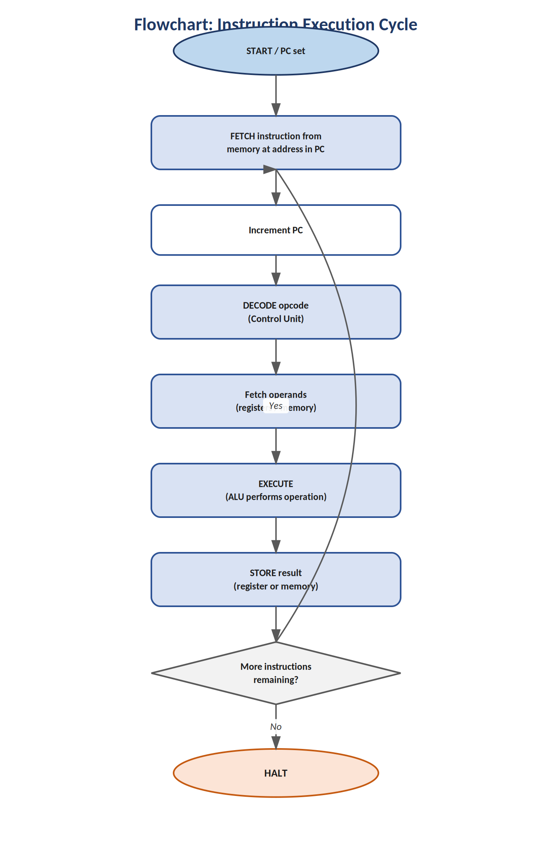
Process Flow of the Instruction Cycle

Figure 2.2 - Fetch-Decode-Execute cycle as a flowchart

The Performance Equation
The three quantities - Instruction Count, CPI, and Clock Cycle Time - combine into the fundamental CPU performance equation:
Execution Time = Instruction Count x CPI x Clock Cycle Time
Clock Cycle Time is simply the reciprocal of the clock frequency (a 2 GHz processor has a 0.5 ns cycle time). Several factors push CPI upward and therefore increase execution time even when the instruction count stays the same:
- Memory access time: a cache miss forces the CPU to wait many extra cycles while data is fetched from slower main memory.
- Instruction complexity: complex (CISC-style) instructions that perform multiple micro-operations internally need more cycles than simple RISC-style instructions.
- Pipeline stalls: data, control, and structural hazards in a pipelined CPU force 'bubble' cycles to be inserted so that no incorrect result is produced.

Benchmarking
Because CPI and clock speed alone do not tell the whole story, standardised benchmark programs (such as the SPEC suite) are run on different machines under identical conditions so that their execution times can be fairly compared. From these runs, derived metrics such as MIPS (Million Instructions Per Second), throughput, and speedup are computed, giving a practical, application-level measure of performance rather than a purely theoretical one.

Question 3: 8085 versus 8086 Architecture
The Intel 8085 and Intel 8086 represent two consecutive generations of microprocessor design, and comparing them illustrates how architectural choices directly influence program execution, multitasking capability, and efficiency.

Concept Map
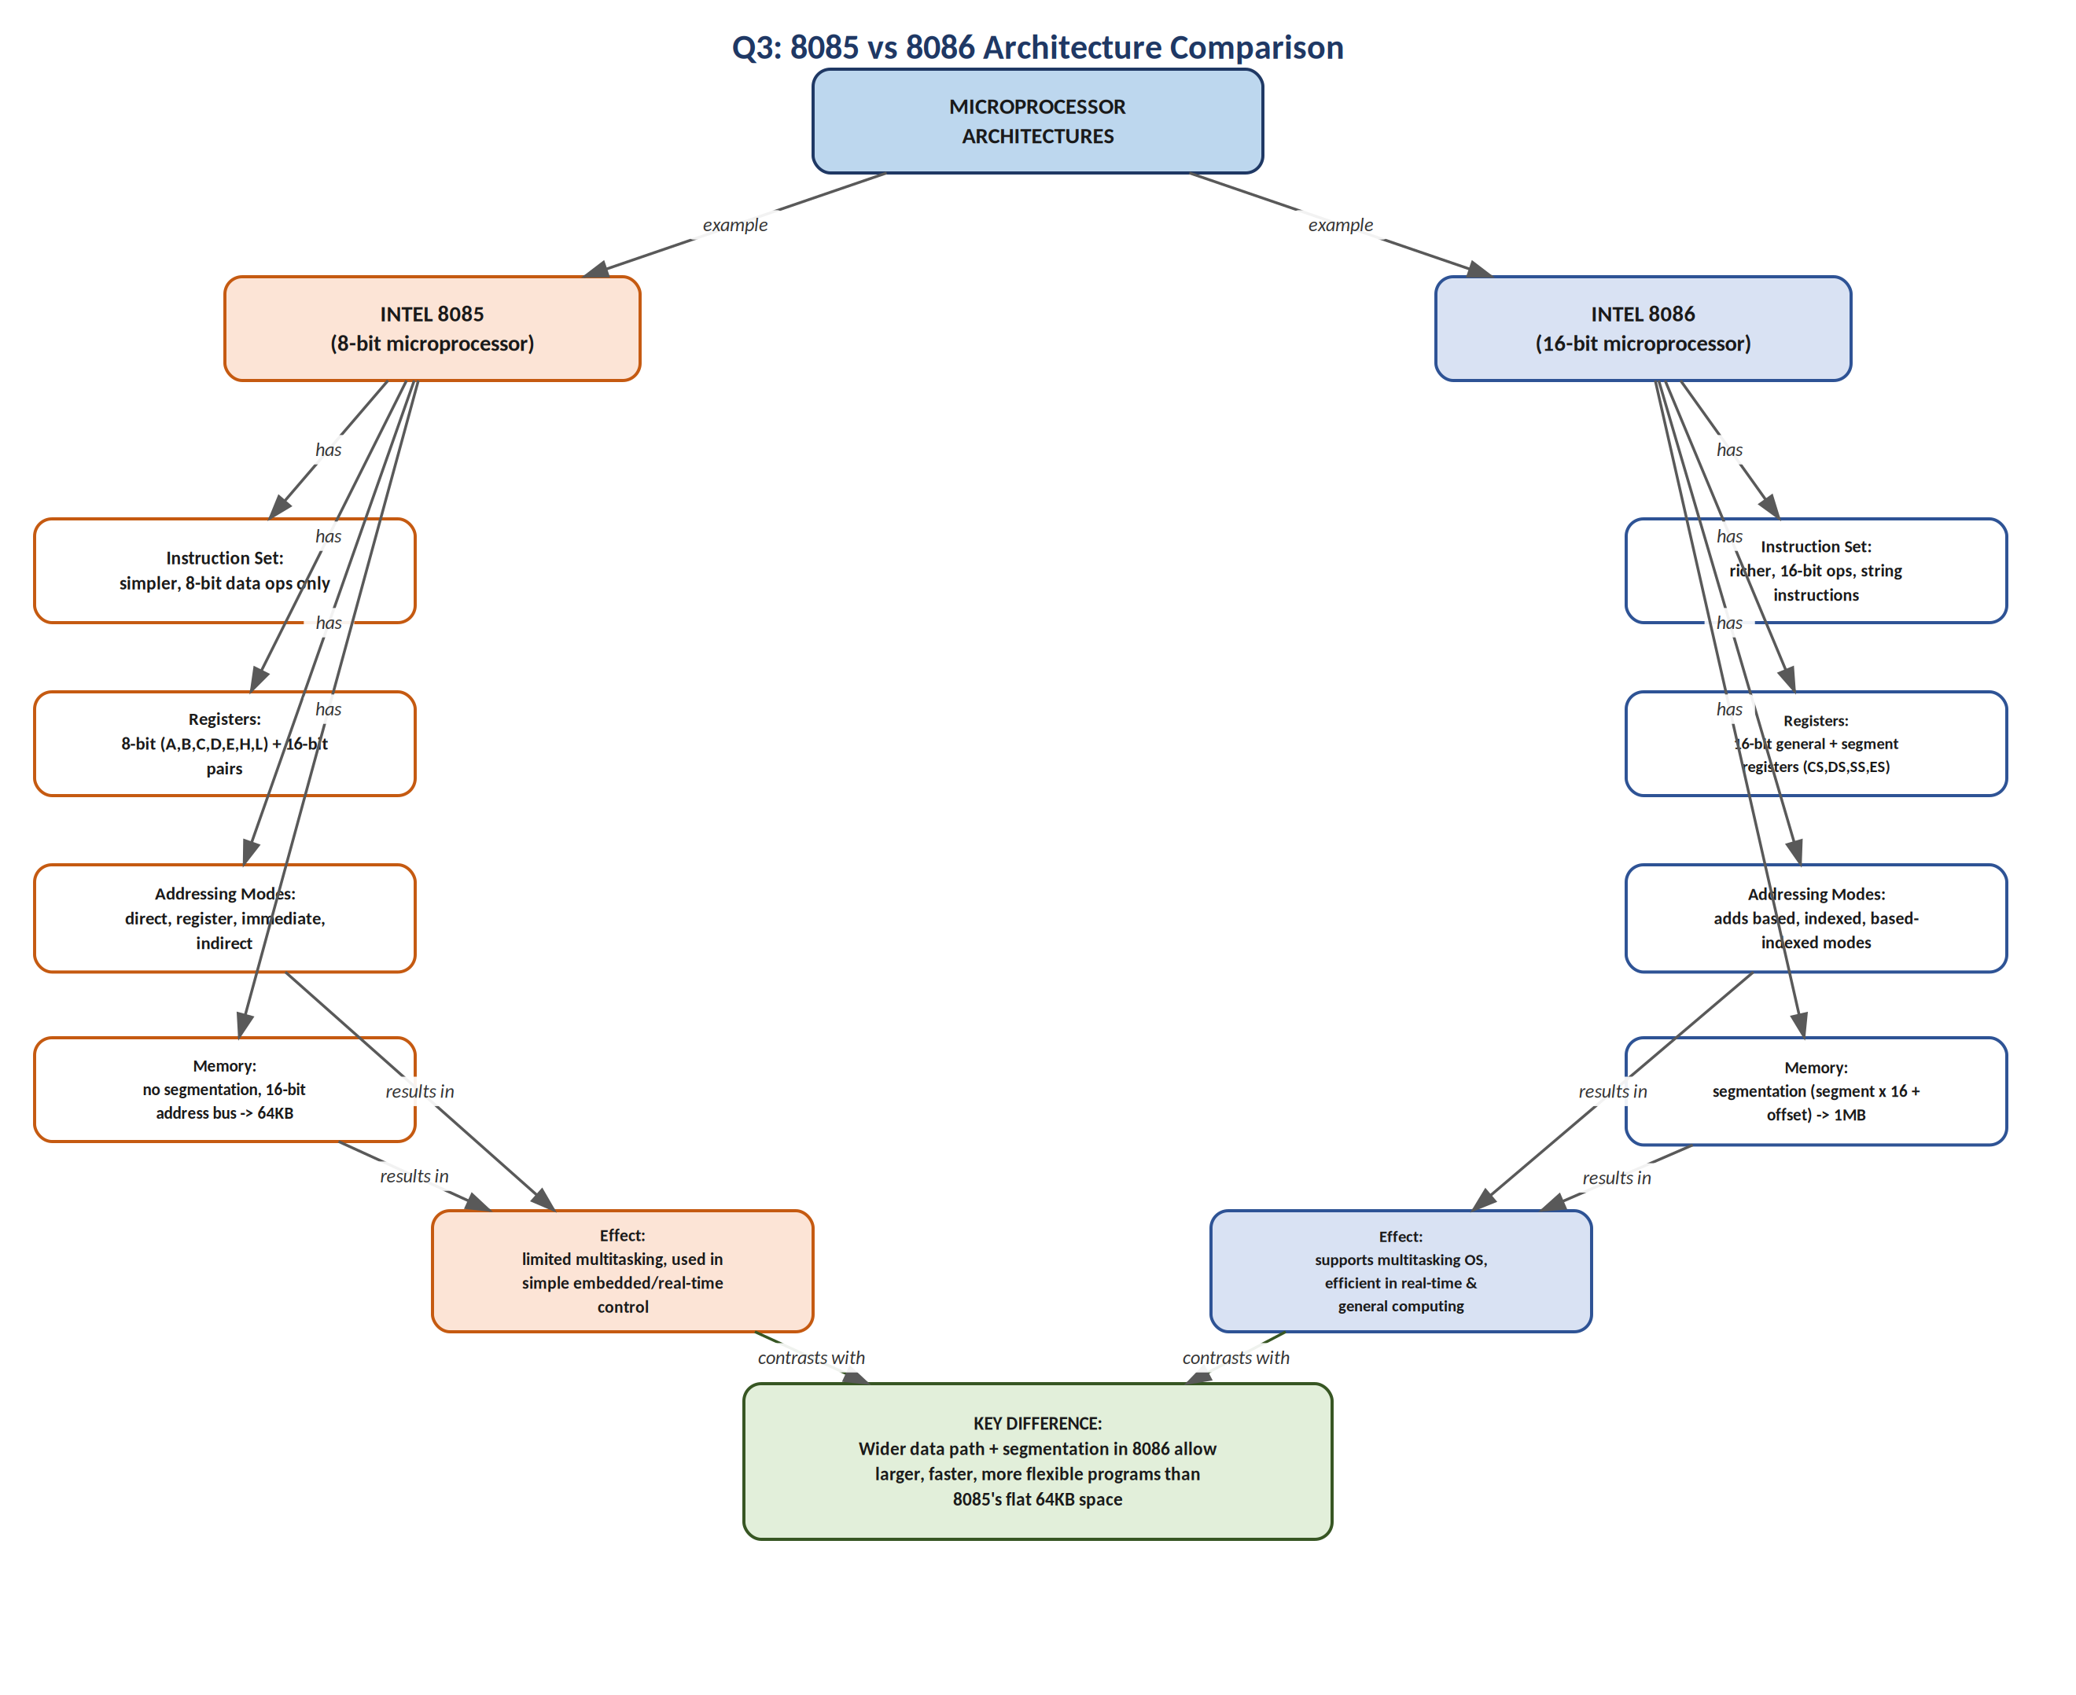
Figure 3.1 - Comparison of 8085 and 8086 architectures

Explanation of Relationships
The 8085 is an 8-bit microprocessor. Its instruction set operates only on 8-bit data, its general-purpose registers (A, B, C, D, E, H, L) are 8 bits wide (although some can be paired as 16-bit register pairs such as BC, DE, HL), and it supports direct, register, immediate and indirect addressing modes. Because it has a 16-bit address bus with no segmentation, its entire addressable memory space is a flat 64 KB, which is adequate only for small, dedicated, real-time control applications such as traffic light controllers or simple appliances.
The 8086, in contrast, is a 16-bit microprocessor with a considerably richer instruction set - including string manipulation instructions absent in the 8085. It introduces four segment registers (CS, DS, SS, ES) that implement a segmented memory model: a physical address is formed as (segment x 16) + offset, which extends the addressable space to 1 MB despite registers remaining 16 bits wide. The 8086 also adds based, indexed, and based-indexed addressing modes that make it far more convenient to manipulate arrays and data structures.

Impact on Execution, Multitasking and Efficiency
- Program execution: the 8086's wider data path and richer instruction set allow more work to be done per instruction, and its instruction queue (a primitive pipeline) allows fetch and execute to overlap, both of which speed up program execution compared to the 8085.
- Multitasking capability: segmentation in the 8086 lets different programs or program modules be relocated into separate segments without address clashes, which is a prerequisite for the multitasking operating systems that followed; the 8085's flat, unsegmented 64 KB space offers no such isolation.
- Efficiency in real-time applications: the 8085, being simpler, has short and predictable instruction timings that suit tightly-constrained embedded control loops, whereas the 8086 sacrifices some of that predictability for far greater processing power and memory reach, making it better suited to general-purpose and multitasking-oriented real-time systems.

Question 4: Addressing Modes and Instruction Types
An addressing mode is the method by which an instruction specifies the location of the operand it must work on. The choice of addressing mode is closely tied to the type of instruction being executed, and it has a direct, measurable effect on memory access time, instruction size, and execution speed.

Concept Map
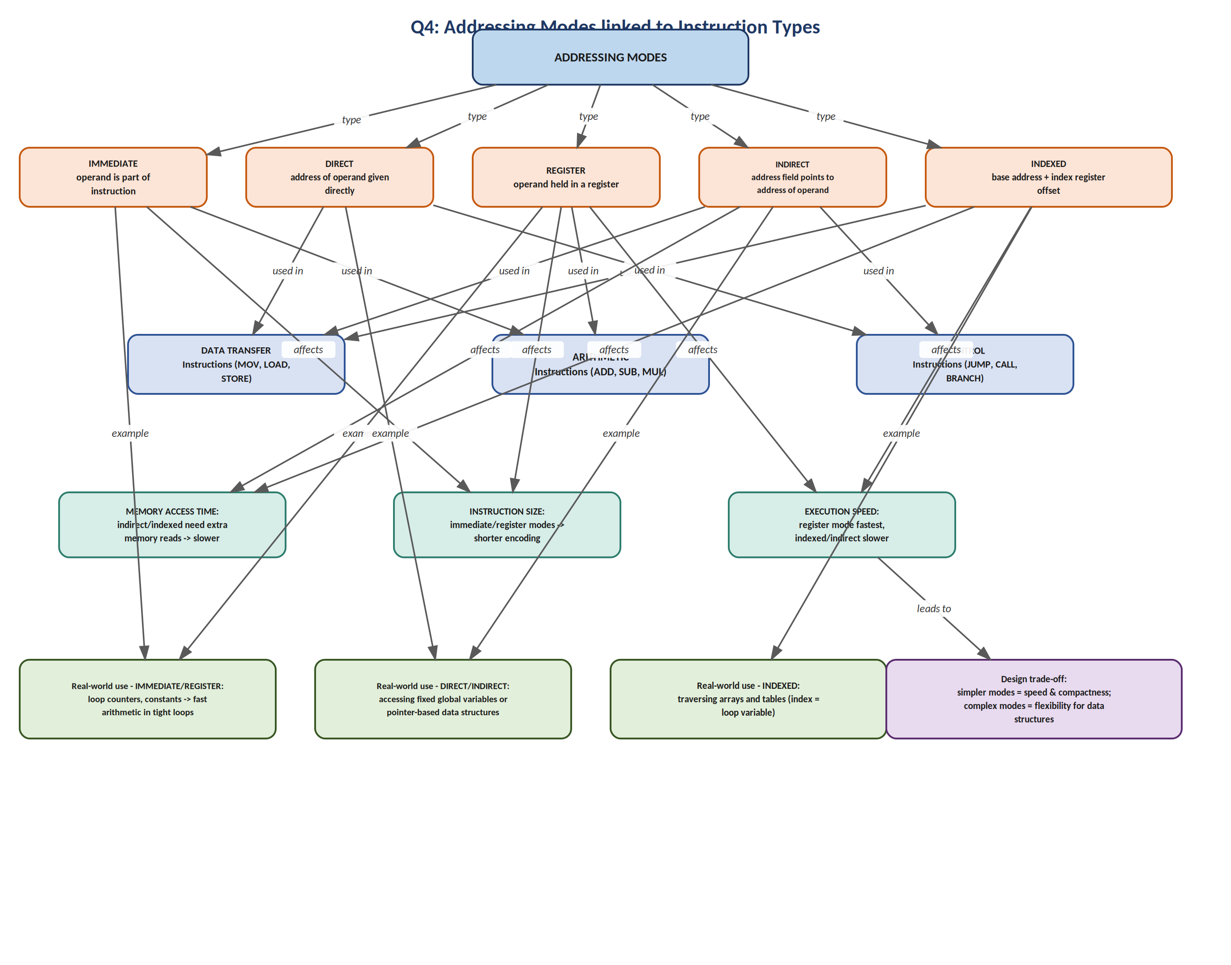
Figure 4.1 - Addressing modes connected to instruction types

Explanation of Relationships
- Immediate addressing: the operand value is embedded directly in the instruction (e.g., MOV A, #05H). It requires no extra memory access, so it is fast and produces compact instructions - ideal for arithmetic instructions that use constants.
- Direct addressing: the instruction contains the actual memory address of the operand (e.g., MOV A, 2000H). It is simple to decode but needs one memory access to fetch the operand, and is typically used in data transfer instructions moving fixed, known variables.
- Register addressing: the operand is already held in a CPU register (e.g., ADD B). Since no memory access is needed at all, this is the fastest mode and is heavily used in arithmetic instructions inside tight loops.
- Indirect addressing: the instruction's address field holds the address of another location that itself contains the operand's address (e.g., MOV A, @HL). This needs two memory accesses, making it slower, but it is essential for data transfer and control (jump) instructions that work with pointers.
- Indexed addressing: the effective address is computed as a base address plus the contents of an index register. It is slightly slower than direct addressing because of the extra addition step, but it is the natural choice for instructions that traverse arrays and tables.

Effect on Memory Access Time, Instruction Size and Speed
Modes that avoid a separate memory reference for the operand (immediate, register) are both the fastest and the most compact in terms of encoded instruction size, because no full address field needs to be stored or fetched. Modes that must dereference memory (direct, indirect, indexed) trade that speed and compactness for flexibility: indirect and indexed modes in particular add one or more extra memory cycles, which increases both execution time and, in many instruction sets, the size of the instruction word needed to hold the addressing information.

Real-World Scenarios
- Immediate/Register modes: loop counters and constant thresholds in a tight arithmetic loop, where speed matters most.
- Direct/Indirect modes: accessing a fixed global variable directly, or following a pointer to a dynamically allocated node in a linked list using indirect addressing.
- Indexed mode: stepping through the elements of an array or a lookup table, where the index register is incremented on every loop iteration.

Question 5: Number Systems, Instruction Representation, Memory and Debugging
At the hardware level, every instruction, address and piece of data inside a computer exists purely as binary - as sequences of 0s and 1s corresponding to the on/off states of transistors. Hexadecimal is not a separate 'machine language' - it is a human-convenience notation that maps cleanly onto binary and is used wherever people, rather than circuits, need to read or write that data.

Concept Map
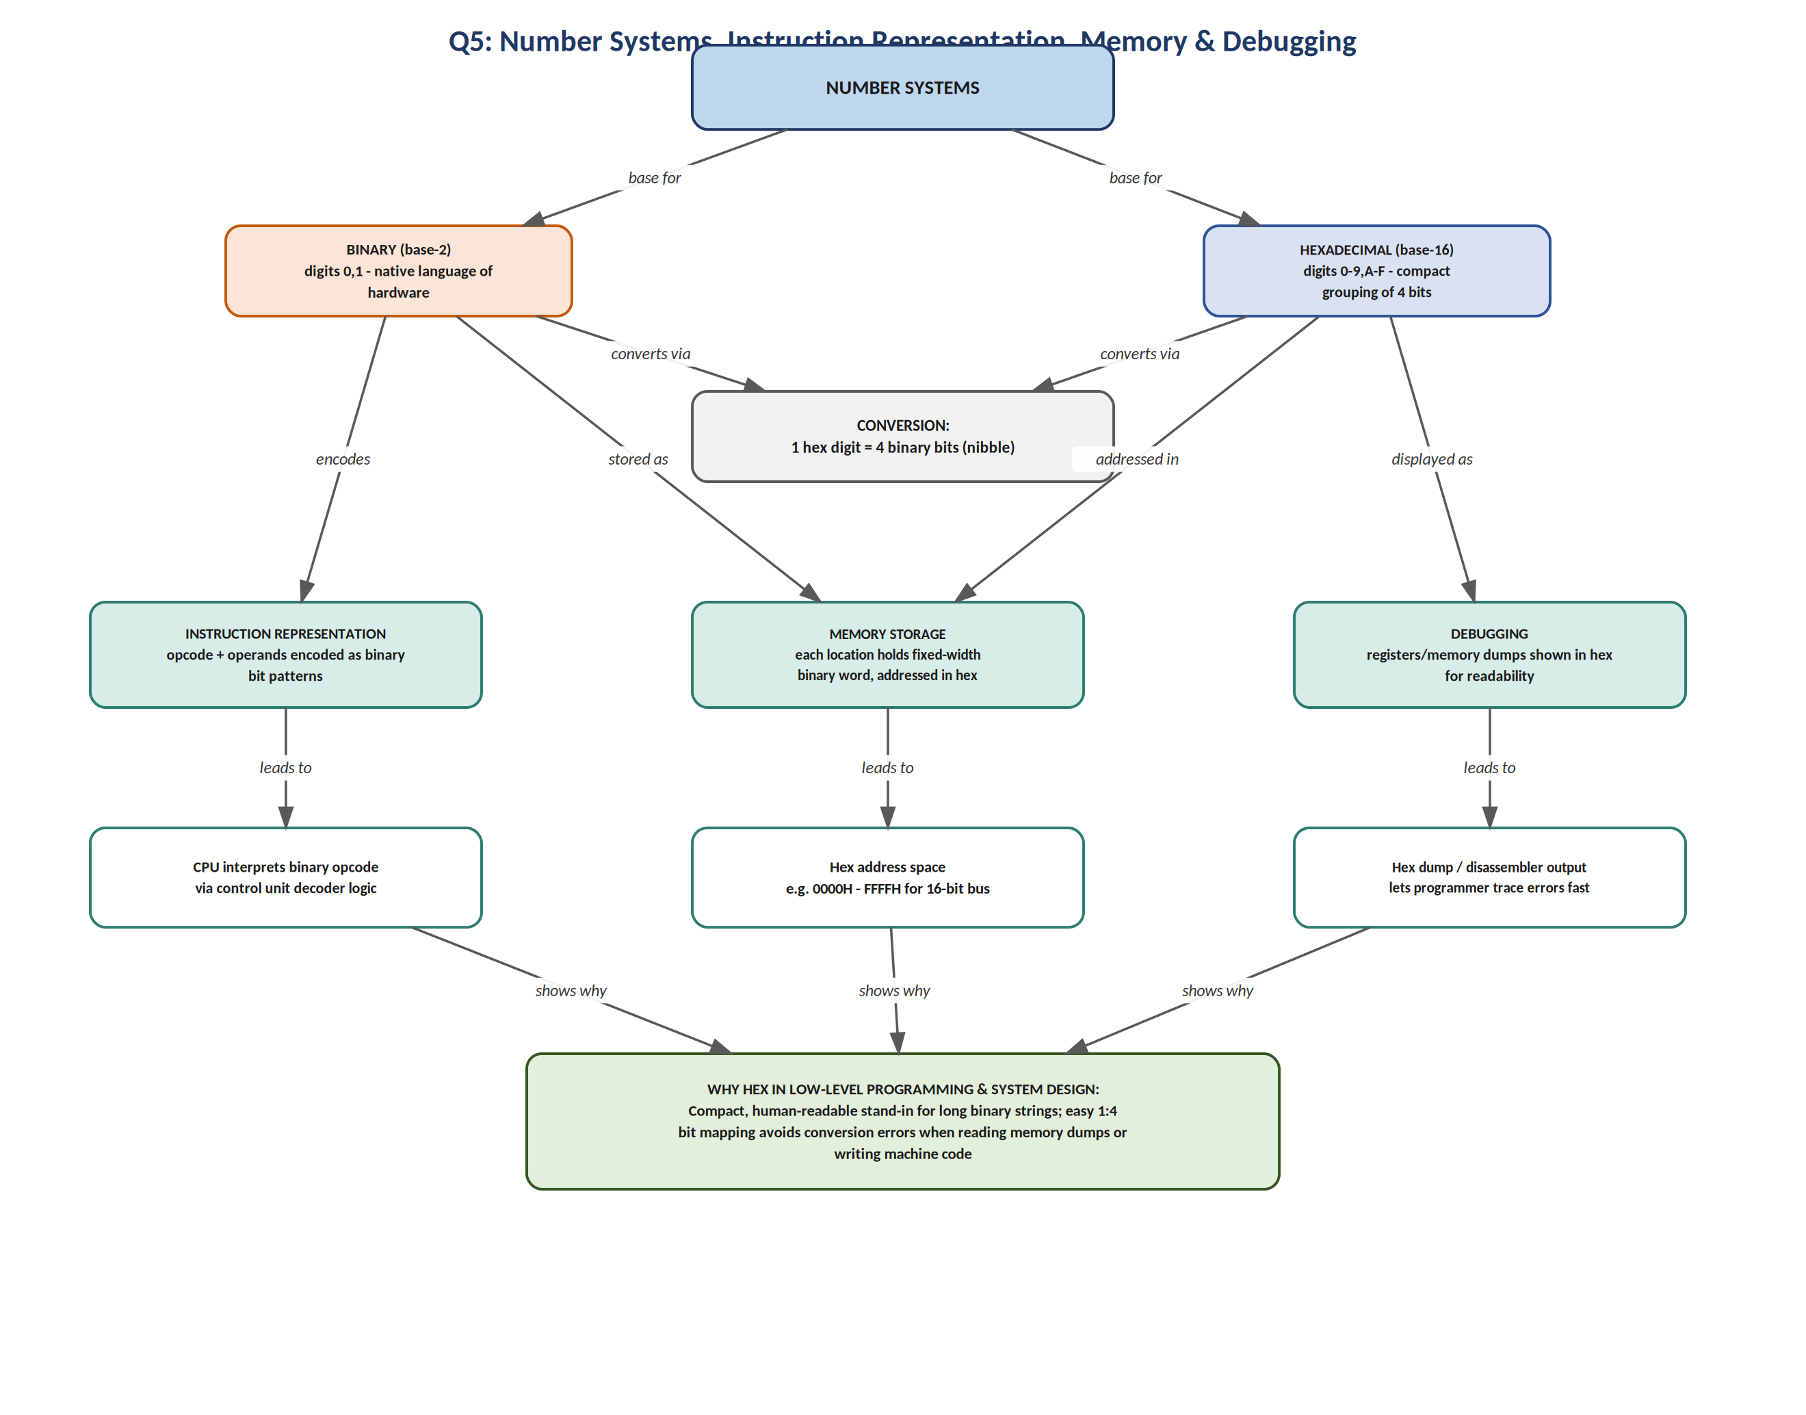
Figure 5.1 - Number systems linked to instruction representation, memory and debugging

Explanation of Relationships
Binary (base-2) is the native language of the hardware because each bit corresponds directly to a transistor or memory cell being on or off. Hexadecimal (base-16) is convenient for humans because it groups bits four at a time: exactly one hexadecimal digit (0-9, A-F) represents exactly one nibble (4 bits) of binary, so conversion between the two systems is a direct, error-resistant, digit-by-digit mapping rather than a full mathematical calculation.

Conversion Process
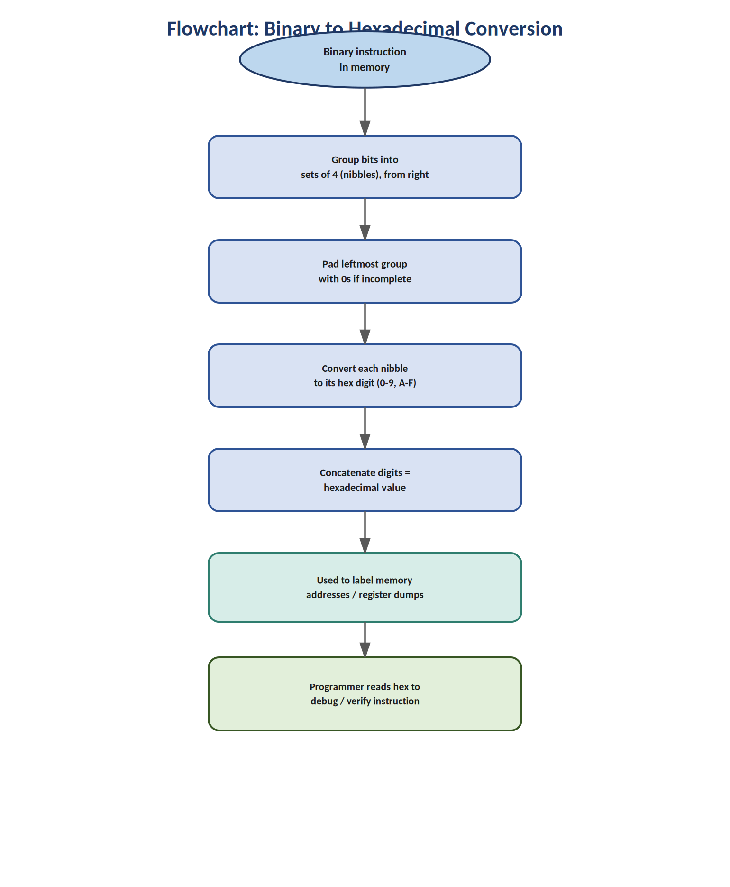
Figure 5.2 - Converting a binary instruction to hexadecimal
Instruction representation: every machine-code instruction is stored and executed as a binary bit pattern - an opcode field followed by one or more operand fields - which the Control Unit's decoder logic interprets directly. When an assembler translates a mnemonic instruction such as MOV A, B into machine code, the result is this binary pattern; it is commonly displayed to the programmer in hexadecimal purely for readability.
Memory storage: each memory location holds a fixed-width binary word, and is itself identified by a binary address travelling on the address bus. Because raw binary addresses are long and hard to read (for example, an 16-bit address bus gives addresses from 0000000000000000 to 1111111111111111), documentation and debugging tools almost universally express the address range in hexadecimal instead - for example, 0000H to FFFFH.
Debugging: when a programmer inspects register contents or takes a memory dump to find a fault, both a hardware debugger and a disassembler display the raw binary content in grouped hexadecimal form, since scanning a screen of sixteen-character binary strings is slow and highly error-prone compared to scanning four-character hexadecimal strings.

Why Hexadecimal Dominates Low-Level Programming
Hexadecimal is preferred in low-level programming and system design because it is compact (a 32-bit value needs only 8 hex digits versus 32 binary digits), it aligns naturally with byte and word boundaries (every byte is exactly two hex digits), and its 1:4 mapping to binary is simple enough to convert by inspection - eliminating the arithmetic errors that come from manually converting between binary and decimal.

